Software Requirements Specification
for
Automatic Traffic E-challan Generation Using Computer Vision
Version 1.2 approved
Prepared by :-
405237 Shrayank Mistry

405240 Parag Nankar

405241 Gaurav Patil

405256 Prathamesh Tambe

Sinhgad College of Engineering,Vadgaon(bk.)
3rd October 2018
Table of Contents
Table of Contents ii
Revision History ii
1. Introduction 1
1.1 Purpose 1
1.2 Document Conventions 1
1.3 Intended Audience and Reading Suggestions 1
1.4 Product Scope 1
1.5 References 1
2. Overall Description 2
2.1 Product Perspective 2
2.2 Product Functions 2
2.3 User Classes and Characteristics 3
2.4 Operating Environment 3
2.5 Design and Implementation Constraints 3
2.6 User Documentation 3
3. External Interface Requirements 4
3.1 User Interfaces 4
3.2 Hardware Interfaces 5
3.3 Software Interfaces 5
3.4 Communications Interfaces 5
4. System Features 6
4.1 System Feature 1 6
4.2 System Feature 2 (and so on) 6
5. Other Nonfunctional Requirements 8
5.1 Performance Requirements 8
5.2 Security Requirements 8
5.3 Software Quality Attributes 8
6. Other Requirements 9
Appendix A: Glossary 9
Appendix B: Analysis Models 10

Revision History
Name | Date | Reason For Changes | Version
Purpose, Intended Audience | 1-10-2018 | We assumed audience as end user instead of developer. | 1.0
Sequence Diagram | 3-10-2018 | We forgot 2 modules : Input,End user | 1.1

Introduction

Purpose
The purpose of this document is to explain the product scope, system details that is being developed and give a general idea about its various modules and general functionality of how the system will perform under various conditions.

Document Conventions
For primary Headings: Font Size: 18 Font: Times
For secondary Headings: Font Size: 14 Font: Times
For text: Font Size: 11, Font: Arial

Intended Audience and Reading Suggestions
The purpose of this document is to make the developers aware of the system being developed, the working of the system, its various modules and the limitations, the system will face under various conditions.

Product Scope
The purpose of are system is to automate e-challan generation when vehicles cross zebra crossing during traffic signal. The system is based detection of the vehicles that have broken the rule, license plate detection of the vehicle breaking rule and effective challan generation. We will have a database server the has information of all the vehicle registered. Above all, we hope to provide a smooth, easy and hassle-free system for the traffic authority.

References
1] License Plate Detection and Localization in Complex Scenes Based on Deep-Learning IEEE 2018

2] Characters Feature based Indian Vehicle License Plate Detection and Recognition. IEEE 2017

3] Deep Learning System for Automatic License Plate Detection and Recognition IEEE 2017

Overall Description

Product Perspective
The product is designed to update the existing system of challan generation which includes two people who manually check if rule is broken and then generate challan.

- Image Preprocessing: Cropping the image above the zebra crossing and removing noise to make it ready for license plate detection.

- License Plate detection: Multiple License plate from vehicles that have broken the rule will be detected.

- Feature Extraction: The alphabets and numbers on the number plate are extracted and recognized.

- Database Verification: The obtained registration number is searched in the database for owner name.

- E-challan Generation: An e-challan will be generated in the name of the owner.

Product Functions

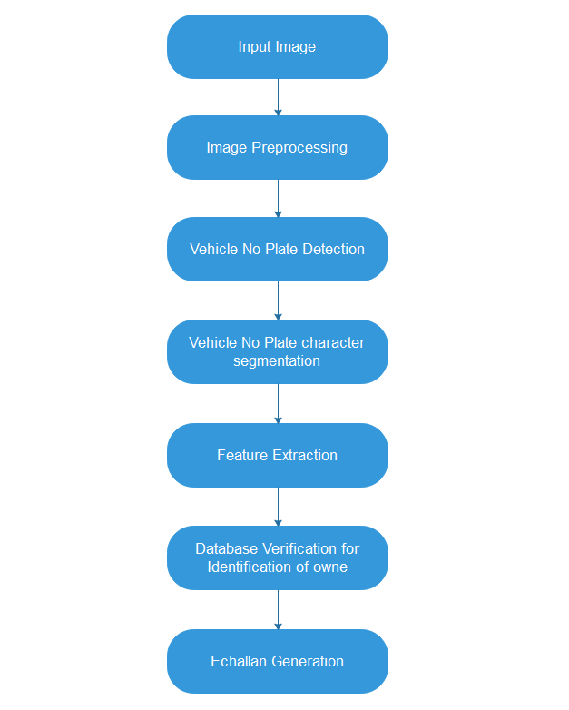

User Classes and Characteristics
There are two types of users that interact with the system: owner of the vehicle who breaks the rule, traffic authority who monitors the system. Each of these two types of users has different use of the system so each of them has their own requirements.

The owner of the vehicle will get a message or email regarding the challan generation along with the image of when his vehicle broke the rule, location, date and time.

The traffic authority will monitor the system for any errors during its operation, and take respective action to shut the system down during failure.

Operating Environment
Operating System: Linux or Windows

Platform: Python

Api for Vehicle Details: parivahan.gov.in/rcldstatus

Api for Sms: way2sms

Design and Implementation Constraints
Hardware limitations can be minimized by using a good resolution camera. The system must use a good network connection to constantly access the api for owner information and sending sms. The processor must be fast to process multiple traffic locations information at the same time. Two apis that are being used i.e. way2sms and parivahan.gov.in/parivahan/rcldstatus must be up and running constantly for system to work efficiently.

Assumptions and Dependencies
Image is taken without any interference such that it is not blur, corrupted etc. and taken in normal climatic conditions.

Api for vehicle details is available 24/7 and gives instant results.

Api for sms sending to vehicle owner is available 24/7.

External Interface Requirements

User Interfaces
The traffic authority personal and administrators interact with the system through a web-portal, an administrator should also be able to log in to the web-portal where he/she can administer the system.

Submit
Vehicle No:

Vehicle No : XXXXXXXXXX

Challan 1:
Challan No : XXXXX
Date & Time
Fine: Rs. XXX

Challan 2:
Challan No : XXXXX
Date & Time
Fine: Rs. XXX

Total Fine : Rs. XXX

After Clicking on Particular Challan:

Challan No : XXXXX

Date & Time

Fine: Rs. XXX

Vehicle No: XXXXXX

Mobile No : XXXXX

Place: XXXXXXX

Proof:
Image of Rule Violation

3.2 Hardware Interfaces
Traffic Camera will be used for capturing Image.

3.3 Software Interfaces
Software Used | Description
Operating System | We have chosen windows os for its best support and user friendliness.
Python | To implement the project we have choosen python language for its more interactive support and its features.
Api for vehicle | parivahan.gov.in/rcldstatus
Api for sms | way2sms

3.4 Communications Interfaces
- Api for vehicle details( parivahan.gov.in/rcldstatus)
This api is used to get owner information of the vehicle from its registration number

- Api for sending sms(way2sms)
This api is used for sendin sms to owner regarding rule violation and fine generated.

.

System Features
The system being developed has two main features:
- Detecting the vehicles that have violated the rule.
- Generating e-challan for the vehicles that have broken the rule.

Detecting of rule violation
4.1.1 Description and Priority
When the signal is red the vehicles that have violated the rule have to be detected, this is a high priority requirement.

4.1.2 Stimulus/Response Sequences
- Image is taken when signal goes red.
- The image taken is cropped from the zebra line.
- Noise is filtered out of the image.
- The vehicles in existing image have broken the rule.
- Traffic authorities receive all the registration number of vehicles that have broken the rule.

4.1.3 Functional Requirements
REQ-1:
A high resolution camera should be used to take the image, when signal goes red.

REQ-2:
The image taken should be filtered to remove noise, and it should be cropped to detect
vehicle.

Automatic E-challan Generation
4.1.1 Description and Priority
Once the traffic authorities receive the registration number, the system will automatically generate challan for all the vehicles, this is high priority.
4.1.2 Stimulus/Response Sequences

- System will get all the registration number of vehicles that have violated the rule.
- Using the government api for finding vehicle information, system will get owner
information of all the registration numbers detected.
- Once owner information is found, using way2sms api message about rule violation and fine is recorded.

4.1.3 Functional Requirements

REQ-1:
The registration number detected by system should be correctly detected by the system.

REQ-2:
The government api for owner information should be running 24/7 and respond quickly for the system to be efficient.
REQ-3:
The way2sms api should be running 24/7 and send message to respective owner .

Other Nonfunctional Requirements

Performance Requirement
All the vehicles that have violated the rule at particular signal have to be detected instantly
and without any errors in normal climatic conditions is a particular hardware requirement that has to be meant.

- Camera used should take image exactly when signal goes red.
- Image should be sent to system quickly and without any faults.
- System should recognize number correctly.
- The apis necessary should be running constantly to get vehicle information and send e-challan information.

Security Requirements
The user data obtained from apis should be stored securely and should not be misused to generate wrong challans. The rules regarding the rules of api should not be violated.

Software Quality Attributes
The system should be robust as multiple request to process rule violation may occur at the same time in a particular region.

The system must be reusable in different regions by making the system adapt to various different hardware interfaces.

The system must be reliable and run 24/7 under any circumstances

Appendix A: Glossary

API - Application Program Interface

OS - Operating System

Appendix B: Analysis Models

Class Diagram
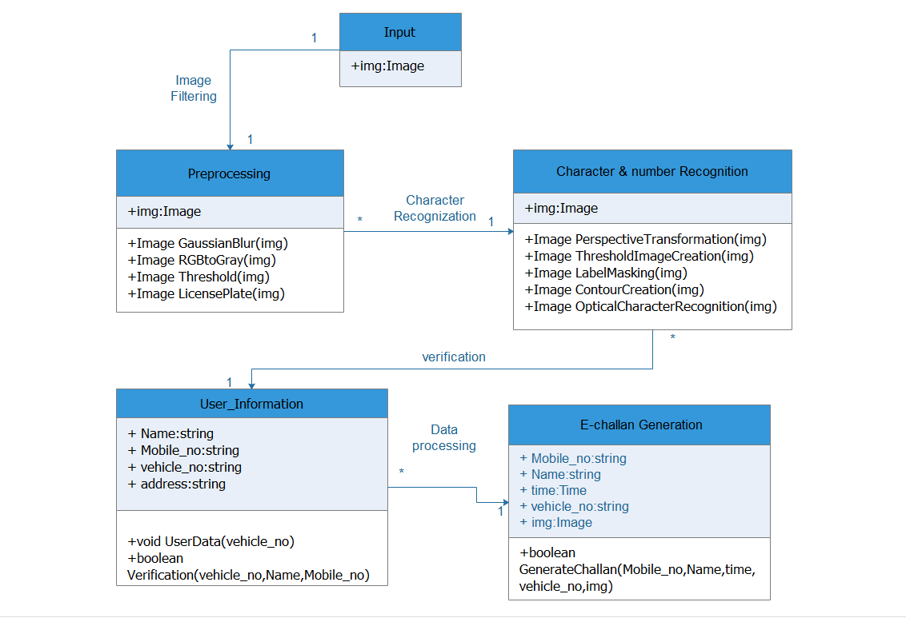

Use Case Diagram

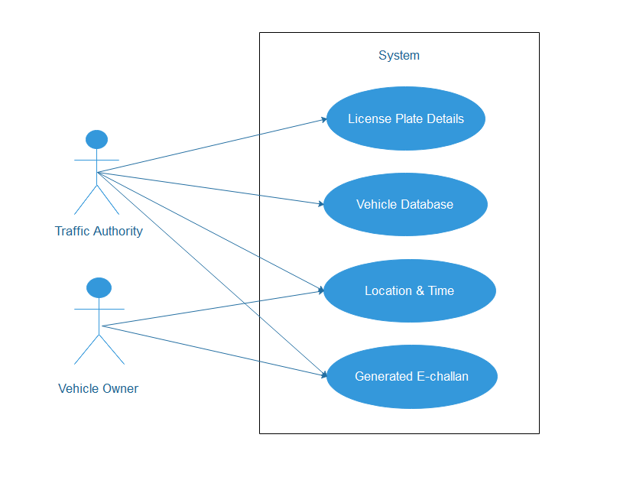

Sequence Diagram

